1. **Agenda**: There may be many method calls in a single statement as shown below.



But we want **to debug a particular method 🡺 getName()**.

1. In this case **Smart Step Into** becomes very helpful.  
     
     
   Graphical user interface, text, application

   Description automatically generated  
     
   **Jatin**🡺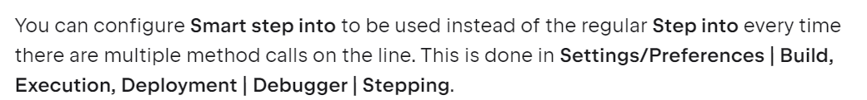



1. 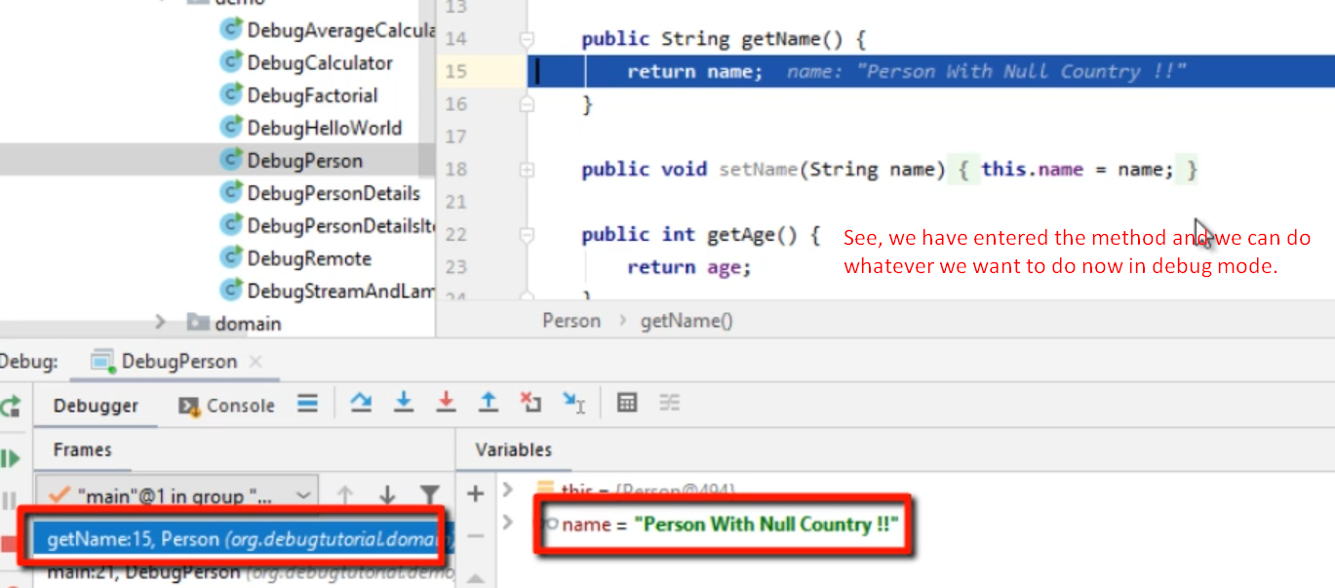

Run to Cursor : Another Navigation Useful Feature

1. There is another **Navigation useful feature** 🡺 **Run to cursor**.

1. But if there is any other breakpoint along the way, the control will be paused there.   
   **Solution**: “Force Run to Cursor”  
   Graphical user interface, text

   Description automatically generated **NOTE**: It will ignore all the breakpoints on the way if it comes across.